***Section 3: Cisco Packet Tracer:***

***Step 1:***

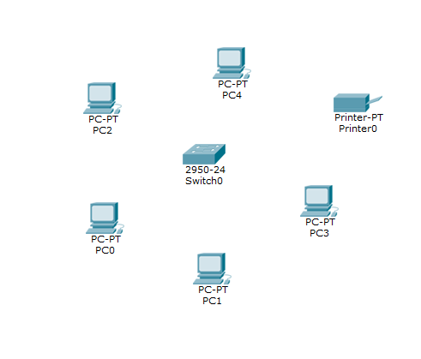

In the bottom-left panel, you can select various components such as **End Devices**, **Routers**, **Switches**, and **Hubs**, among others.  
From the **End Devices** category, we selected **5 generic PCs** to establish connections between them.  
Additionally, we included **1 switch** and **1 network printer** to complete the setup.

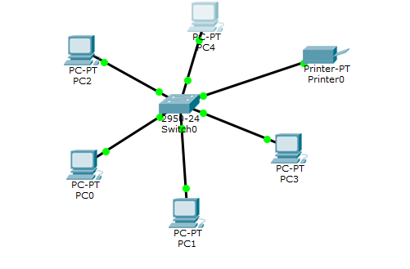

1. Open the **Connections** tab and select the **Copper Crossover Cable**.
2. Click on **PC 0**, then select **FastEthernet0** as the connection point.
3. Drag the other end of the cable to the **switch** and connect it to an available port.
4. Repeat the process for the other PCs:
5. Select each PC, click on their respective **Fast Ethernet** ports, and connect them to the switch.
6. Similarly, connect the **printer** to the switch following the same steps.

***Step 2:***

***Pc 0:***

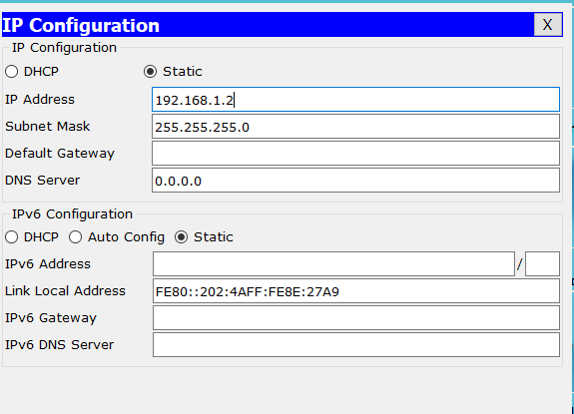

Next, we will assign IP addresses to the systems:

1. Click on **PC0** to open its configuration menu.
2. Navigate to the **Desktop** tab and select **IP Configuration**.
3. Enter the IP address **192.168.1.2** for **PC0**.
4. The subnet mask will be generated automatically.

***Pc 1:***

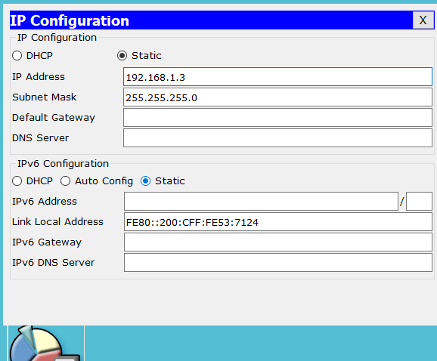

1. Click on **PC1** to open its configuration menu.
2. Navigate to the **Desktop** tab and select **IP Configuration**.
3. Enter the IP address **192.168.1.3** for **PC1**.
4. The subnet mask will be generated automatically.

***Pc 2:***

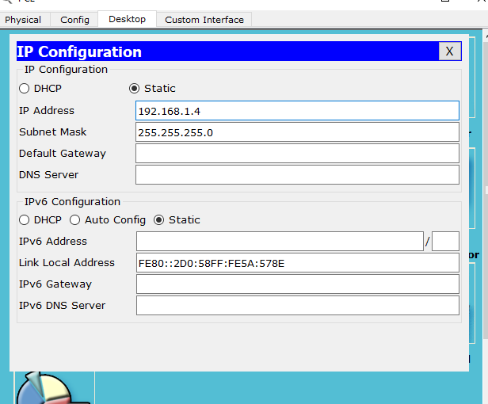

1. Click on **PC2** to open its configuration menu.
2. Navigate to the **Desktop** tab and select **IP Configuration**.
3. Enter the IP address **192.168.1.4** for **PC2**.
4. The subnet mask will be generated automatically.

***Pc 3:***

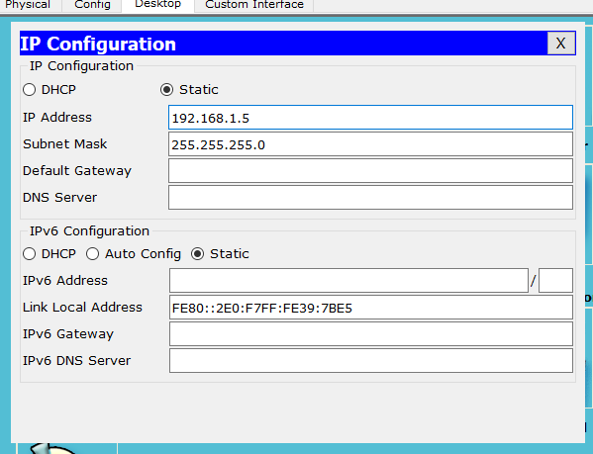

1. Click on **PC3** to open its configuration menu.
2. Navigate to the **Desktop** tab and select **IP Configuration**.
3. Enter the IP address **192.168.1.5** for **PC3**.
4. The subnet mask will be generated automatically.

***Pc 4:***

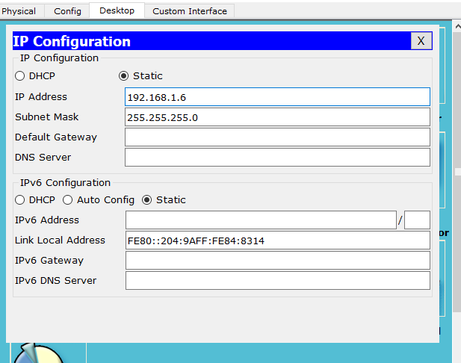

1. Click on **PC4** to open its configuration menu.
2. Navigate to the **Desktop** tab and select **IP Configuration**.
3. Enter the IP address **192.168.1.6** for **PC4**.
4. The subnet mask will be generated automatically.

***Printer:***

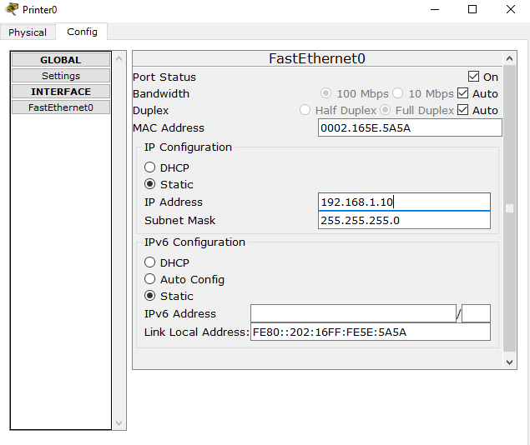

1. Click on **Printer** to open its configuration menu.
2. Navigate to the **Desktop** tab and select **IP Configuration**.
3. Go to settings.
4. Enter the IP address **192.168.1.10** for **Printer**.
5. The subnet mask will be generated automatically.

***Step 3:***

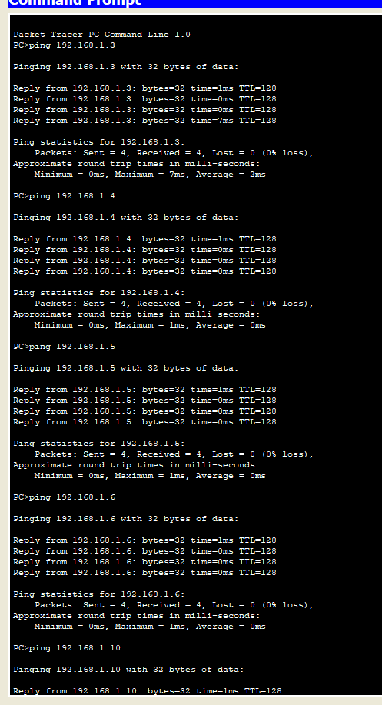

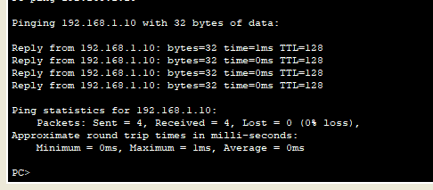

1. Open the menu for PC0 and navigate to the Command Prompt.
2. Use the ping command to test connectivity with each device:
3. Start by entering the IP address of PC1, then proceed with the IP addresses of PC2, PC3, PC4, and finally the printer.
4. For each ping test, you will observe that four packets are sent and four packetsarereceived, indicating successful connectivity.
5. This confirms that the connection between PC0 and the respective devices (PC1, PC2, PC3, PC4, and the printer) is established and all devices are reachable from PC0.
6. Repeat this process on other PCs to ensure connectivity across the network.

***Step 4:***

1. Open the menu for PC0 and navigate to the Command Prompt
2. Use the ping command to connectivity of devices with printer.
3. Enter the ip address of printer.
4. Click on enter.
5. you will observe that four packets are sent, and four packetsarereceived, indicating successful connectivity
6. This will show that your printer is successfully connected with pc0.
7. Follow this with each pc

Pc1:

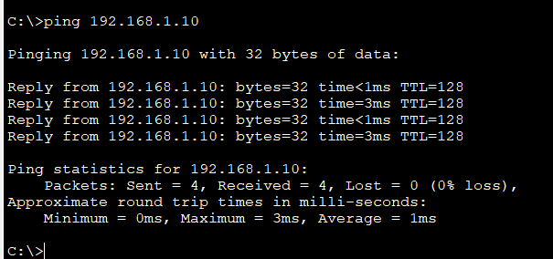

Pc 2:

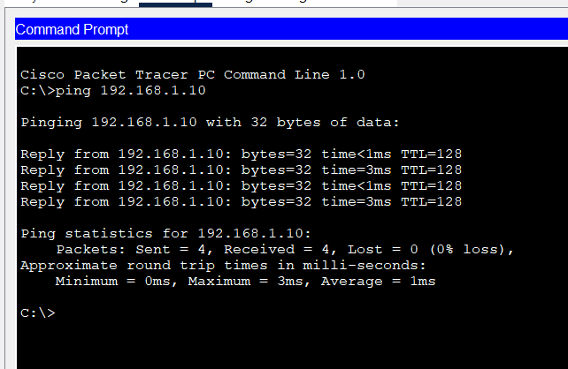

Pc 3:

Pc 4:

Pc 5:

